

**BACHELOR OF ENGINEERING**

**IN**

**ELECTRICAL AND ELECTRONIC ENGINEERING**

**“MINI PROJECT REPORT”**

**TITLE: SIMPLE INVERTER**

DONE BY: GUIDE:

* SHAWIN KRISHNA S - 1NH18EE740 Mr. MOHAN DAS
* BELLEM SREEKANTH REDDY – 1H18EE706
* S M ADIL – 1NH18EE745

**DEPARTMENT OF ELECTRICALAND ELETRONICS ENGINEERING**

CERTIFICATE

Certified that the mini project work entitled “**SIMPLE INVERTER”** carried out by **Shawin Krishna S – 1NH18EE740, Bellam Sreekanth Reddy – 1NH18EE706, S M Adil – 1NH18EE745** are bonafede students of New Horizon College of Engineering submitted the report in completion of project at department of Electrical and electronics engineering, New Horizon College of engineering during the academic year 2019-2020. It is certified that all the correction/suggestions indicated for internal assessment have been incorporated in the report deposited in the department library. The project report has been approved as it satisfied the academic requirements’ in respect of project work prescribed for said degree.

Project guide: HOD - EEE

Name of the guide Dr. S Ramkumar

Mr. Mohan Das

**SIMPLE INVERTER**

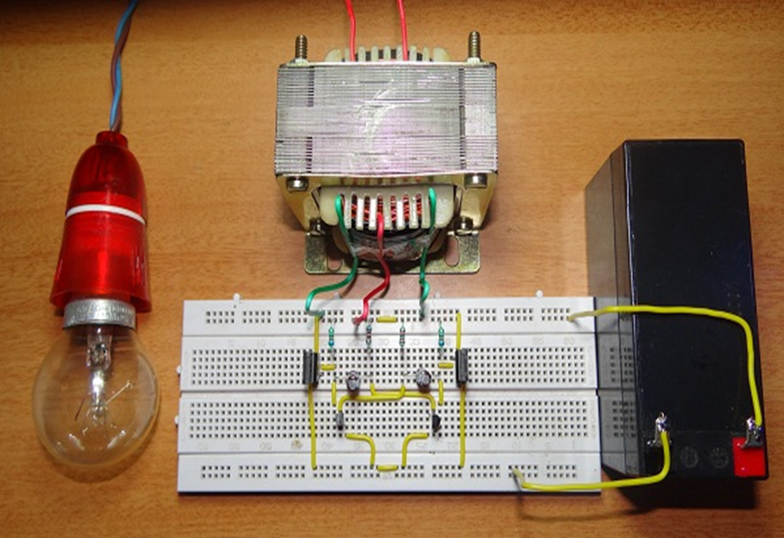

**ACKNOWLEDGEMENT**

We have taken efforts in this project. However, it would not been possible without the kind support and help of our term and teacher. We would like to extend our sincere thanks to all of them.

We are highly indebted to our project guide Mr. Mohan Das for their guidance and constant supervision as well as for providing necessary information regarding the project and also for their support in completing the project.

We would like to express our gratitude towards our parents and all those who have helped us directly and indirectly for their kind co-operation and encouragement which helped us in completing the project.

Finally, we would like to thank God for giving us an opportunity to study in this institution.

**INTRODUCTION**

Inverter is a device which is used to convert DC current to AC current. Inverter is required at a place where to get AC power supply from the mains. An inverter circuit converts the DC power to AC power. Inverters are classified into two types they are quasi or modified inverters and true sine wave inverter. The power which we got from the inverter can be used for an electric appliance like Mobile phones, television, Computers, etc. The Step-up transformer can be used to create main voltages from resulting AC. The inverter that is implemented in this following circuit gives a square wave inverter and it works with the devices which do not require pure sine wave of AC.

**ABSTRACT**

The common basic idea in every inverter circuit is to produce an oscillation. This can be done using the given DC and apply these oscillations across the primary coil of the transformer by amplifying the given current. Depending upon the number of turns in primary coil as well as in the secondary coils the primary voltage is then stepped up to a higher voltage.

This project is presented using an impedance source power inverter. it is called as a controlled method for implementing DC- AC conversion.

The impedance source inverter gives a unique impedance network for coupling the inverter main circuit to the power source.

**LIST OF COMPOMENTS**

|  |  |  |
| --- | --- | --- |
| **S.NO** | **NAMES** | **VALUES** |
| 1 | MOSFET | IRF 630 (2) |
| 2 | Transistor | 2N2222 (2) |
| 3 | Capacitor | 2.2uf (2) |
| 4 | Resistor | 680 (2), 10K (2) OHM |
| 5 | Transformer | 12-0-12 V |
| 6 | Battery | 12V |

**TABLE OF CONTENTS:-**

**DISCUSSION**

**SPECIFICATION OF COMPONENTS:**

**RESISTOR:**

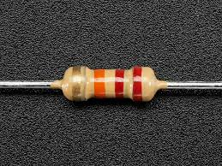

Resistor is a thing which resists to the flow of current and also acts as voltage dividers. Resistance is mostly used in this range when more power rating high value resistors are available. Resistors are also called as “passive devices”. They also contain source of power or amplification. it only attenuates or reduce the voltage signal which passes through the resistor. Resistance is the opposition to the substance which offers the flow of electric current. The unit of resistance is said to be “ohm”.

**CAPACITOR:**

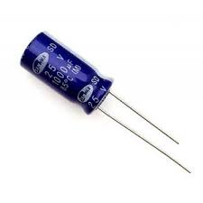

Capacitors are used in Oscillatory AC circuits or timing circuits. Capacitors are also used as filters.it is used to store energy. In case of filters which are needed are the capacitances of the capacitor as well as the input supply frequency in order to get the capacitive resistance. A capacitor has a maximum rating of 2.2uf, and the maximum voltage that the capacitor can sustain is 25V. 2.2uf is its capacitance rating.

**TRANSISTOR:**

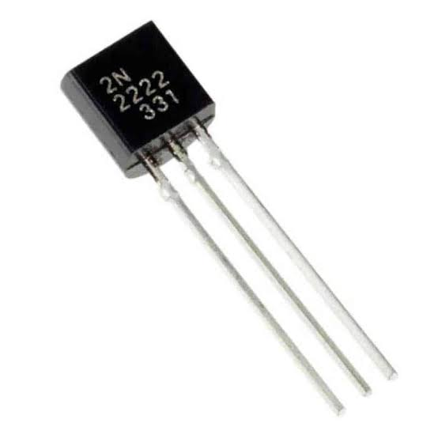

A transistor is a semiconducting device which is used to switch or amplify electrical power and electronic signals. It consists of semiconducting materials that has at least three terminals for connecting it with an external circuit. If a current or voltage applied to one pair of the transistor’s terminals, the current is controlled through another pair of terminals. We can also say that the controlled output power can be higher than that of the controlling input power.

**TRANSFORMER:**

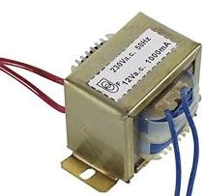

A transformer is said to be a passive electrical device. A transformer can transfer electrical energy between two or more circuits. A transformer has a coil with varying current that produces a varying magnetic flux. In turn it also induces a varying electromotive force across a second coil. Electrical energy is transferred without the metallic connection to the two coils, between the two circuits. The step-up transformer will convert 12v DC to 220v AC.

**MOSFET:**

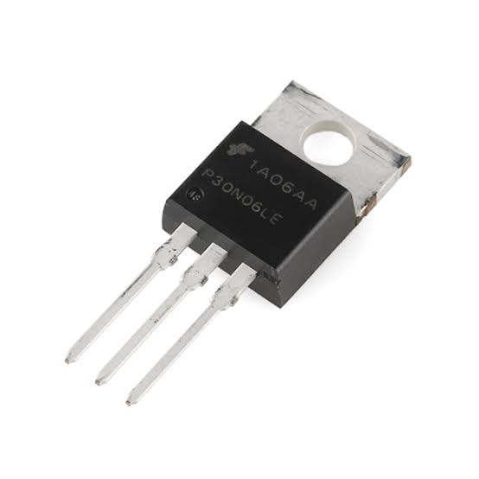

The MOSFET gave here act as a field-effect transistor. It is fabricated by the controlled oxidation of a semiconductor and also has an insulated gate, typically silicon. The determination of the electrical conductivity of the device is done by the voltage of the covered gate. The ability to change the conductivity with the given amount of applied voltage is used for the amplification of signals and also switching electronic signals.

MOSFET – Metal Oxide Semiconductor Field Effect Transistor

**CIRCUIT DIAGRAM:-**

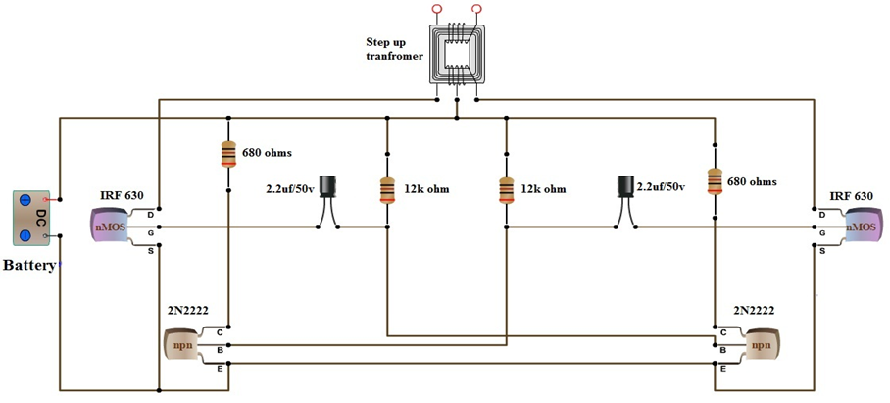

**WORKING:-**

The circuit used here can be classified into three parts they are amplifier, oscillator and transformer. The required frequency for the oscillator is 50Hz of AC supply.

It is possible to achieve by building an A stable multivibrator that can produces a square wave at a frequency of 50Hz. The circuit consists of R1, R2, R3, R4, C1, C2, T1 and T2.

Each transistor that is given in the circuit produces inverting square waves. The frequency can be decided by the values of R1, R2 and C1 (R4, R3 and C2 are identical). The frequency formula for square wave generated is given as

F=1/ (1.38*R2*C1)

The inverting signals from the oscillator are used to amplify the power MOSFETs M1 and M2. The step-up transformer will receive the amplified signals with its center tap connected to 12V DC.

To convert 12V to 220V the turn’s ratio of the transformer must be 1:19. The transformer is designed in such a way to combine both the inverting signals to generate a 220V alternating square wave as an output.

The loads up to 40w can be powered by using a12v DC battery. The design given here is inefficient to increase the capacity of the inverter. To increase its efficiency the number of MOSFETs must be increase.

**ADVANTAGES:-**

* The circuit is made with a Simple design.
* The number of parts count is also low.
* It saves more space.
* It also avoids noise pollution.
* It also has the capacity of fast transient response.
* The construction of this circuit is cheap.

**DISADVANTAGES:-**

* When the input – output difference is large, it gives low efficiency.
* Low efficiency will give significant heat dissipation.
* It is not capable exclusively for step-down operation.

**REFERENCE:**

* [**www.electronicshub.com**](http://www.electronicshub.com)

**THANK YOU**